English
Spellings- RECAP ALL SPELLING RULES

READING SKILLS
Inference
Vocabulary- word meaning
Retrieval – information
Summarising

Maths (Example questions)
TOPIC- RECAP
Metric units- converting metric measures
Kilomteres and miles
Arithmetic recap

PE
Athletics
Cricket- consolidating batting skills using 6v6 games
Revision
Grammar
Spelling- tion, sion
Arithmetic- fractions, decimals and percentages
Long division

Year 6
Summer 1
Week one
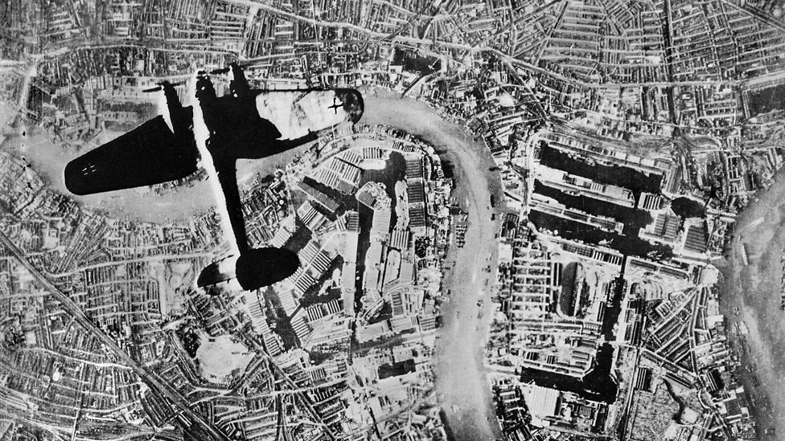

RE
Transforming the spirit
Know about the ascension
Reflect on what it was like for the disciples

History
Why did WW2 start? Who was involved

Reading
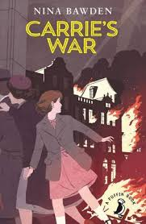
Art
BLITZ art- making buildings and backgrounds

FACTS  Please learn these facts ready for a test on Monday | 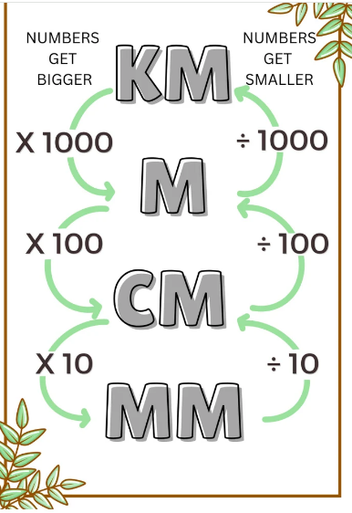
Project | Please keep practising the following  - Times tables ALL  - Extra arithmetic practise use past papers  - Spellings – recap previous spellings learnt  - Grammar – use bbc website to support  - READ READ READ every day
Messages | A huge well done to all the children who completed the Easter homework!  

