English
Spellings- RECAP ALL SPELLING RULES

READING SKILLS
Inference
Vocabulary- word meaning
Retrieval – information
Summarising

Maths (Example questions)
TOPIC- RECAP
Starter- grid referencing, times tables
Measures, arithmetic
Recap lesson measures, recap percentages
Recap ratio
Kilograms, grams, litres, millilitres

PE
Athletics
Cricket- bowling skills
Revision
Grammar
Able and ible
Percentage s
Fractions
Measures
Rounding
Year 6
Summer 1
Week one
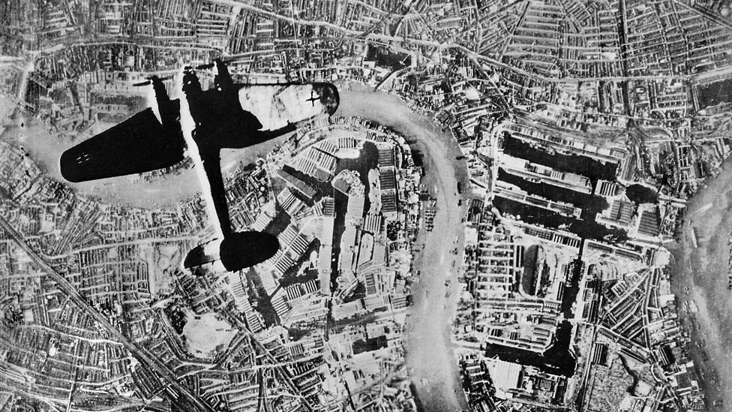

RE
Transforming the spirit
Know about the ascension
Reflect on what it was like for the disciples

History
to understand life changed during the war -what did people do to help during the war?

Reading
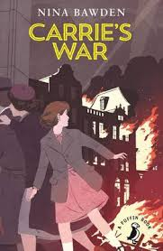
Art
Creating the other half of a picture

