Maths (Example questions)
TOPIC- Fractions, decimals and percentages
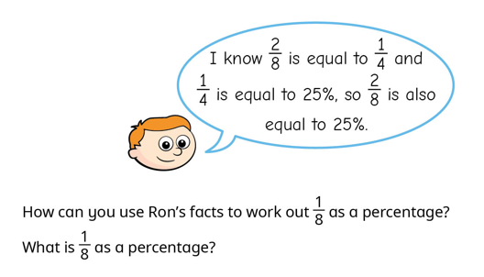

English
Spellings- ed, est endings
Grammar- Past perfect tense
English
Blackberry blue
Features of faiy tales
Past perfect tense
Effective verbs
Power of 3
Write the ending of a fairy tale using learnt features

PE
Football
Health related exercise
Science
To understand the importance of satellites to help monitor our climate.

Year 6
Spring 2
Week one
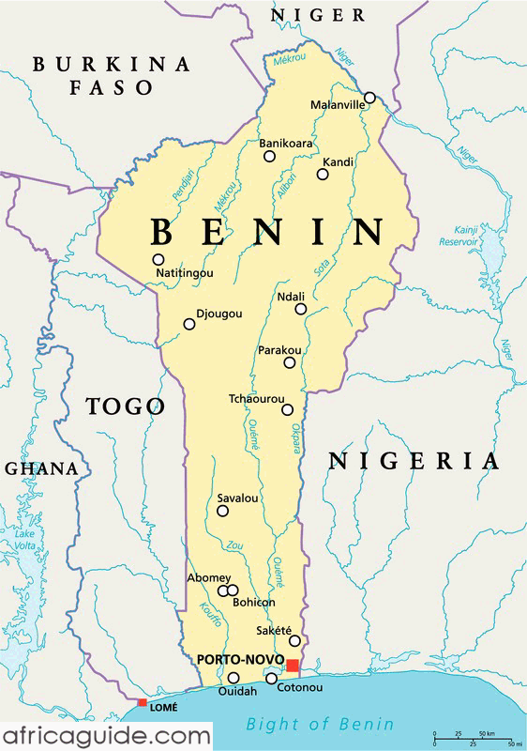

Computing
To enter data and formulas into a
spreadsheet
RE
Create a personal transformation plan for Lent.
Read John 12: 1-11.
Identify people and discuss how they fit into the story.
Consider what the actions and symbols in the story tell us about Jesus as a king.

Reading
Word meaning- using context to support unfamiliar words
To answer literal questions
To answer inference questions

History
When was the Benin Empire?
Where is Benin?

Homework
Maths facts | 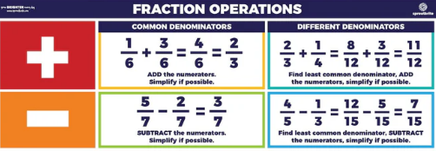
Project | Please keep practising the following  - Times tables ALL  - Extra arithmetic practise use past papers  - Spellings – recap previous spellings learnt  - Grammar – use bbc website to support  - READ READ READ every day
CGP books | Please ensure you check the front of the book for which pages to complete
Messages | Reminder – PE is now Wednesday and Thursday

Homework and Spellings Autumn 2 | Week beginning 24.2.25
Spellings  These will be tested on Monday | Ing words  Trying  Copying  Following  Singing  Moving
Task | Keep practising times tables  Using a calculator  Using a clock  Cooking
Messages | If you would like something extra:  Reading challenge (at the back of the homework diary)

