English
Spellings- sure and ture
Grammar- Word classes
English – Dialogue in stories
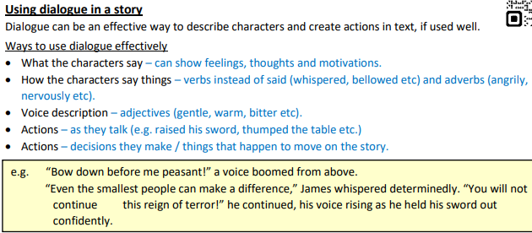
Maths
Decimals – place value
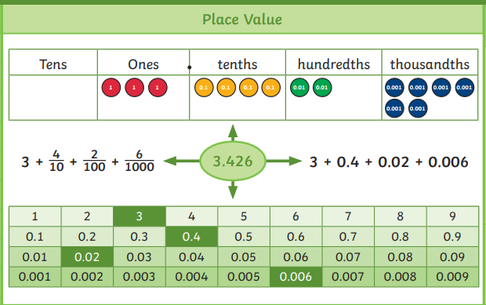

PE
I can play as an attacking pair
I can plan and teach others a drill
I can use my attacking skills in a game situation

To understand what rhythmic gymnastics is
Science
To understand that fossils provide information about living things that inhabited the Earth millions of years ago.
To recognise that living things produce offspring of the same kind, but normally offspring vary and are not identical to their parents

Year 6
Spring 1
Week six



RE

Reading
Word meaning- using context to support unfamiliar words
To answer literal questions
To answer inference questions
D&T
Making fairground rides with rotating parts

Geography

This will be tested on Monday | FACTS  Please learn the attached facts about fractions, decimals and percentages.  This will really help for the next Maths topic.  Please also recap ALL times tables
CGP books | Children are to complete one test from each book. These will be checked on a Monday. Please time the children so they have 10 minutes for each test.
Messages | Please can you ensure CGP books are in every Monday and Reading records are in daily  PE DAYS – WEDNESDAY AND THRUSDAY  Thank you  Mrs Matteoni

