English
To consider how authors develop
character and setting
To describe character, setting and
atmosphere integrating dialogue
To note and develop initial ideas drawing
on research
To describe character, setting and
atmosphere integrating dialogue

Maths (Example questions)
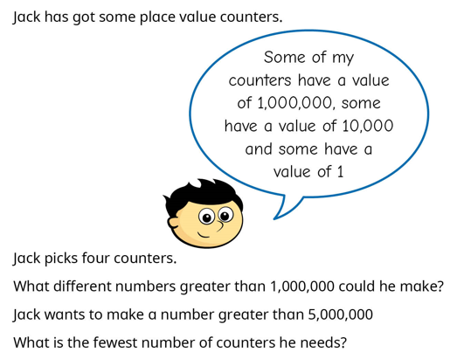
To read and write numbers to 10,000,000
Powers of 10
Compare integers up to 10,000,000
Rounding

PE
To consolidate passing and moving in tag rugby
Swimming
Science
Identify and name a variety of common animals including fish, amphibians, reptiles, birds and mammals.
Identify and name a variety of common animals that are carnivores, herbivores and omnivores.
Describe and compare the structure of a variety of common animals (fish, amphibians, reptiles, birds and mammals, including pets)
Identify, name, draw and label the basic parts of the human body and say which part of the body is associated with each sense

Year 6
Autumn 1


RE
Caritas- catholic social teaching
See-Think-Wonder: Pupils view an image of Eden or a symbolic depiction and use the routine to explore meaning.


Art
To learn about Frida Kahlo and analyse some of her work.
PSHE
I understand that my actions affect other people locally and globally
I understand my own wants and needs and can compare these with children in different communities

Geography
How do California’s mountains, valleys, deserts, and coastline shape the way people live?

Homework and Spellings Autumn 1
Spellings  These will be tested on Monday | 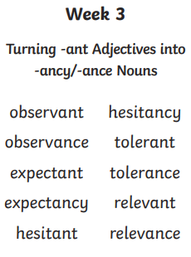
Arithmetic Aerobics | L.O: To subtract whole numbers using the compact method.  - 8576 – 1253 =  - 9544 – 7311 =  - 6543 – 2597 =  - 7931 – 5766 =  - 23548 – 14294 =  - 99632 – 57915 =  - 84361 – 82735 =  - 289457 – 123446 =  - 954632 – 74641 =  - 584632 – 45916 =
Reading focus | Give / explain the meaning of words in context  Ask chn what certain words mean in context. Ask them to read around the word to support with understanding. Choose 5 words in the text.
Homework Project  This is an open task to encourage the children to share their Geography learning with you.  Due: Monday 6th October | To show your understanding of California – create something for our class display  Examples of how you could show your understanding:  Writing/ drawing about California  Comparing weather from California and England  Model of California  Creating a PowerPoint or use Canva
Messages | PLEASE REMEMBER THE CHILDREN MUST ATTEND SWIMMING WHEN POSSIBLE AS THIS IS THEIR ASSESSMENT YEAR  Thank you

