English
To consider how authors develop
character and setting
To describe character, setting and
atmosphere integrating dialogue
To note and develop initial ideas drawing
on research
To describe character, setting and
atmosphere integrating dialogue

Maths (Example questions)
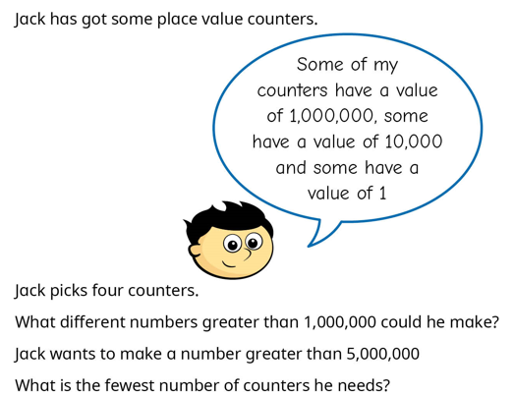
To read and write number to 10,000,000
To times and divide by 10

PE
To consolidate passing and moving in tag rugby
Fitness training
Science
Identify parts of the body
Research Santorio and look for patterns.
Identify parts of the blood.

Year 6
Autumn 1


RE
Caritas- catholic social teaching
See-Think-Wonder: Pupils view an image of Eden or a symbolic depiction and use the routine to explore meaning.


PSHE
Being in my world- to know what my goal for the year is
To understand what fairtrade is

Art
To learn about Frida Kahlo and analyse some of her work.

Geography
Where is California, and what makes its geography unique?

Homework and Spellings Autumn 1 | Week beginning
Spellings  These will be tested on Monday | Homophones  check  cheque  key  quay  bored  board  hire  higher  aloud  allowed
Arithmetic Aerobics | L.O: To add whole numbers using the compact method.  - 2364 + 4125  - 1458 + 2285  - 7456 + 3654  - 1057 + 3647  - 8725 + 3684  - 23,528 + 14,025  - 47,033 + 30,465  - 60,209 + 32, 033  - 21,236 + 4587  - 39,784 + 4785
Reading focus | Give / explain the meaning of words in context  Ask chn what certain words mean in context. Ask them to read around the word to support with understanding. Choose 5 words in the text.
Homework Project  This is an open task to encourage the children to share their Geography learning with you.  Due: Monday 6th October | To show your understanding of California – create something for our class display  Examples of how you could show your understanding:  Writing/ drawing about California  Comparing weather from California and England  Model of California  Creating a PowerPoint or use Canva
Messages | PE Days - Monday  Swimming – Thursday

