English
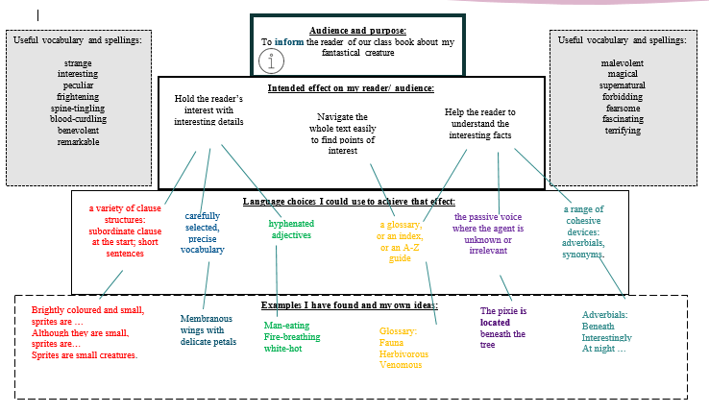
Spellings- 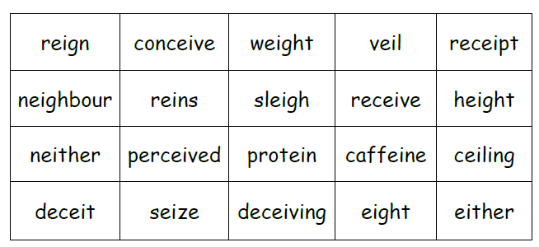 SPAG- Recap
Grammar-
English

Maths (Example questions)
Ratio
To use ratio language
To use the ratio sign

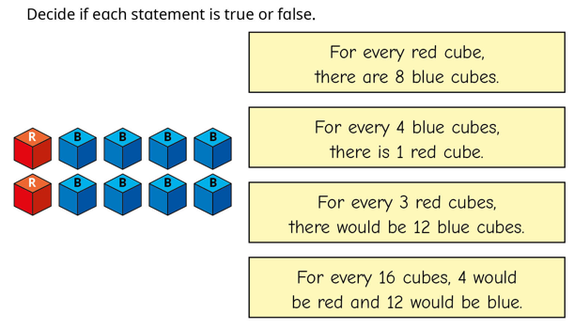

PE
Gym
OAA- outdoor adventurous activity

Science
To understand that fossils provide information about living things that inhabited the Earth millions of years ago.
To recognise that living things produce offspring of the same kind, but normally offspring vary and are not identical to their parents

Year 6
Spring 1
Week one

RE
To explore and reflect on the Wedding at Cana

Geography
Introduction to the change in population in the UK
DT
To know about levers and gears. (Pulleys)

Spellings  These will be tested on Monday | ei words  reign  neighbour  perceived  seize  veil  receipt  caffeine  protein  deceiving  ceiling

Project | Upcycling, upcycling- Encourage your child to choose an item within the house that they do not really use anymore - this could be an old item of clothing, accessory or household item - and upcycle it to make a new item that they will use. Ask them to evaluate the product and identify any areas that they could improve if they were to make it again. They may even want to write a set of instructions so that other people can upcycle the same item too.
CGP books | Children are to complete one test from each book. These will be checked on a Monday. Please time the children so they have 10 minutes for each test.  The pages we would like them to answer will be in the front cover.
Messages | Happy new year to you all. I hope you all had a lovely Christmas break.  

Homework and Spellings Autumn 2 | Week beginning 6.1.24
Spellings  These will be tested on Monday | ei words  weigh  weight  height  eight  being
Task | Upcycling, upcycling- Encourage your child to choose an item within the house that they do not really use anymore - this could be an old item of clothing, accessory or household item - and upcycle it to make a new item that they will use.
Messages | If you would like something extra:  Reading challenge (at the back of the homework diary)

