English
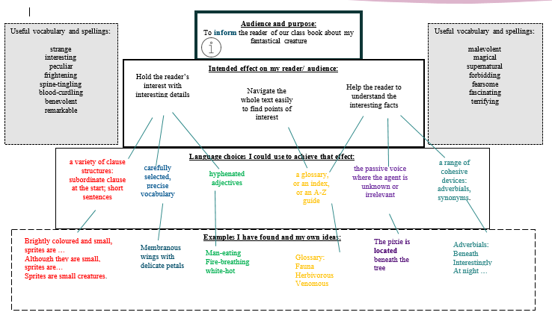
Spellings- SPAG- Recap
Grammar-
English

Maths (Example questions)
Ratio
Ratio word problems
Ratio assessment
Recipes – ratio
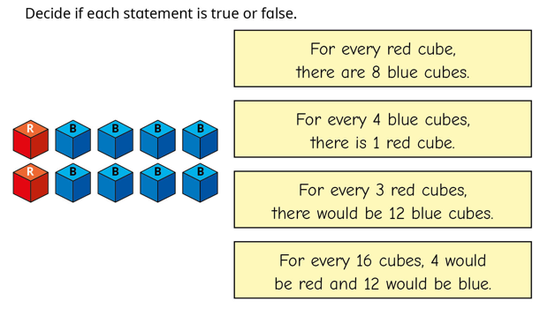

PE
OAA
Gymnastics
Science
To understand that fossils provide information about living things that inhabited the Earth millions of years ago.
To recognise that living things produce offspring of the same kind, but normally offspring vary and are not identical to their parents

RE
Know the seven Sacraments of the Catholic faith
Explain the purpose of each sacrament in the life of the Church
Year 6
Spring 1
Week three



Spellings  These will be tested on Monday | tian, sion, ssion, cian  invention  injection  attraction  comprehension  tension  expression  confession  musician  magician
https://www.bbc.co.uk/bitesize/articles/zyv4qhv

Homework and Spellings Autumn 2 | Week beginning 20.1.25
Spellings  These will be tested on Monday | please go through the endings with your children  https://www.bbc.co.uk/bitesize/articles/zyv4qhv
Project | Upcycling, upcycling- Encourage your child to choose an item within the house that they do not really use anymore - this could be an old item of clothing, accessory or household item - and upcycle it to make a new item that they will use. Ask them to evaluate the product and identify any areas that they could improve if they were to make it again. They may even want to write a set of instructions so that other people can upcycle the same item too.
CGP books | Children are to complete one test from each book. These will be checked on a Monday. Please time the children so they have 10 minutes for each test.  TO COMPLETE
Messages | PLEASE CHECK CGP BOOKS ARE BEING COMPLETED AND CHILDREN ARE READING AND LOGGING IN THEIR HOMEWORK DIARIES  CHN SHOULD ALSO BE LEARNING THEIR SPELLINGS  If you would like something extra:  Arithmetic aerobics  Reading challenge (at the back of the homework diary)

Homework and Spellings Autumn 2 | Week beginning 20.1.25
Spellings  These will be tested on Monday | Hear  Here  See  Sea  Be  Bee
Task | Upcycling, upcycling- Encourage your child to choose an item within the house that they do not really use anymore - this could be an old item of clothing, accessory or household item - and upcycle it to make a new item that they will use.
Messages | If you would like something extra:  Reading challenge (at the back of the homework diary)

