Science Day 1
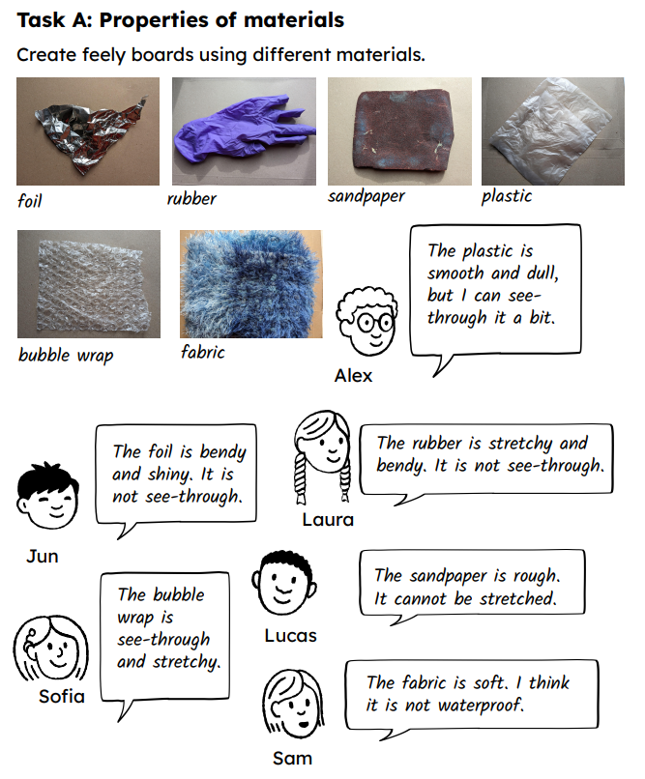
hard | soft | shiny | dull | rough | smooth | see-through  transparent
not-see through  opaque | stiff | rigid | bendy | stretchy | bumpy

