L/O To write a set of instructions to explain how to make a sandwich.
Remember to include:
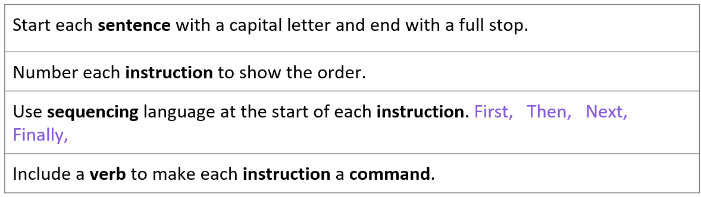

Make a sandwich and say your sentences out loud. This will help you to remember and write your sentences later.
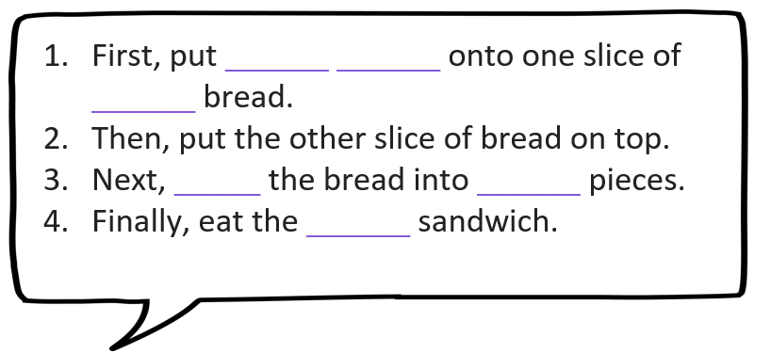

Now can you write your 4 instructions.

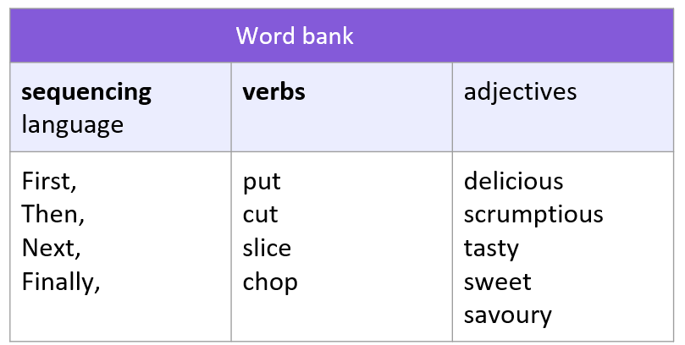
Below are some words that may help you with your spellings.

