 | Year 3 Yearly Overview
 | AUTUMN |  |  | SPRING |  |  | SUMMER
RE | Creation and Covenant |  | Prophecy and Promise | Galilee to Jerusalem |  | Desert to Garden | To the Ends of the Earth |  |  | Dialogue and Encounter
English | Narrative: Mini Rabbit Not Lost  Poetry: “Words are ours” by Michael Rosen  ‘The Magic Box’ by Kit Wright  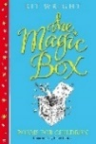  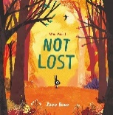  Write to entertain  Retelling, different perspective.  Journey  Narrative  Consolidate use of story shapes to help guide plot structure  Open with either: action, dialogue or description of setting/character  End with a moral message, happy ending, surprise, cliff-hanger  Use of sound and other senses  Fable  Contains a moral lesson  Uses an animal character  Natural or real world  Simple plot  Foolish character  Subordinating conjunctions  Demarcating sentences  Main and subordinate clauses  Reciprocal Reading: Planet Omar Zanib Mian  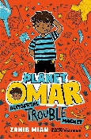 |  | Fable: The Koala Who Could, The Squirrels who Squabbled, The Lion Inside  Non-chronological Report  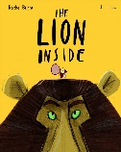  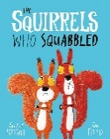  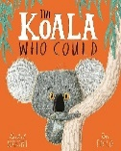  Writing to entertain  Writing to Inform  NCR  Captions and labels  Index  Glossary  A-Z guide  Subordinating conjunctions  Prepositions  Extend sentences with more than one clause  Paragraphs  Commas in a list  Nouns or pronouns for clarity  Reciprocal Reading: Planet Omar Zanib Mian | Narrative: Alice in Wonderland  Persuasive speech: Stella and the Seagull  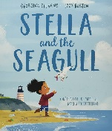  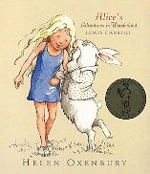  Writing to entertain  Writing to persuade  Narrative  Consolidate use of story shapes to help guide plot structure  Open with either: action, dialogue or description of setting/character  End with a moral message, happy ending, surprise, cliff-hanger  Use of sound and other senses  Dialogue  Show not tell  Power of three  Paragraphs  Speech  First, second and third person narrative  Past, present and future tense  Adverbs  Prepositions  Extend sentences with more than one clause  Apostrophes for omission and singular possession  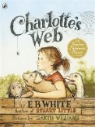  Reciprocal Reading: Charlotte’s  Web by EB White |  | Personal Narrative: The Proudest Blue, Jabari Jumps, Ralph Tells a Story  Poetry: Love That Dog  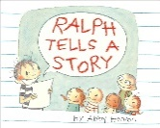  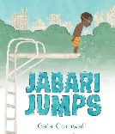  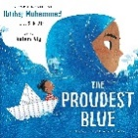    Writing to entertain  Poetry  Narrative  Consolidate use of story shapes to help guide plot structure  Open with either: action, dialogue or description of setting/character  End with a moral message, happy ending, surprise, cliff-hanger  Use of sound and other senses  Dialogue  Show not tell  Power of three  Paragraphs  Poetry  Calligrams  Present perfect verbs  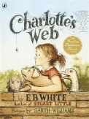  Subordinating conjunctions  Extend sentences with more  than one clause  Inverted commas for speech  Nouns or pronouns for clarity  Reciprocal Reading: Charlotte’s  Web by EB White | Persuasive letters: Speak Up! Clean Up! Look Up!  Instructions: Instructions, Wolf in the Snow  Non-chronological Reports: Amazing Animal Journeys  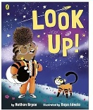  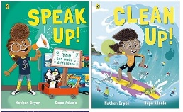  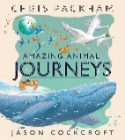  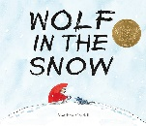  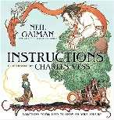  Writing to persuade  Writing to inform  Letters  Layout  Instructions  Easy to follow steps  Chronological order  List of equipment  Command sentences  Present perfect verbs  Prepositions  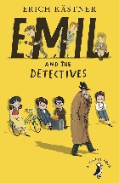  Adverbs  Inverted commas for speech  Reciprocal Reading: Emil and  the Detectives |  |  | Short story: The Iron man  Poem: Joseph Coelho  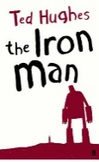  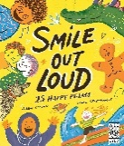  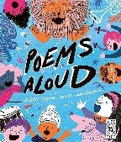  Poems Aloud/Smile Out Loud  Writing to entertain  Poetry  Poetry  Kennings  Narrative  Consolidate use of story shapes to help guide plot structure  Open with either: action, dialogue or description of setting/character  End with a moral message, happy ending, surprise, cliff-hanger  Use of sound and other senses  Dialogue  Show not tell  Power of three  Paragraphs  Subordinating conjunctions  Prepositions  Extend sentences with more than one clause  Inverted commas for speech  Reciprocal Reading:  Emil and the Detectives
Phonics/  Spelling  ESSENTIALS | Review vowel digraphs and KS1 CEW |  | Review suffixes and rules to add them  (s, es, ed, ing, er, est) | Review word endings  (el, le, il, al)  Homophones and near homophones  Apostrophes for contraction and possession |  | Suffixes and rules to add them  (ly, ally, ment, ness, ful, less, tion, ation, sion) | Prefixes  (un, mis, in, re, super)  Short vowel spelt ou  Suffix - ous |  |  | CEW  Long igh sound  Short i as y and s as sc  Silent letters
Maths WHITEROSE | Number –place value  Number – addition and subtraction |  | Number – addition and subtraction  Number – multiplication and division | Number – addition and subtraction  (continued from Autumn 1)  Number – multiplication and division  Measurement – money  Statistics |  | Measurement – length and perimeter  Number – fractions | Number – fractions  Measurement – Time |  |  | Geometry – properties of shape  Measurement – Mass and Capacity
Science | ROCKS  - To compare and group together different kinds of rocks on the basis of their appearance and simple physical properties.  - To describe in simple terms how fossils are formed when things that have lived are trapped within rock.  - To recognise that soils are made from rock and organic matter. |  | LIGHT  - To recognise we need light in order to see things and that dark is the absence of light.  - Light is reflected from surfaces.  - Recognise that light from the sun can be dangerous and that there are ways to protect your eyes.  - Recognise that shadows are formed when light from a light source is blocked by an opaque object.  - Find pattens in the way that the shadows change. | PLANTS  - I can identify and describe the functions of different parts of a flowering plant.  - I can explore the requirements of plant life and growth.  - I can investigate the way in which water is transported within plants.  - I can explore the part that flowers play in the lifecycle of flowering plants including pollination, seed formation and seed dispersal. |  | SCIENCE WEEK  TBC |  | ANIMALS INCLUDING HUMANS  - I can identify that humans and some other animals have skeletons and muscles for support, protection and movement.  - I can identify that animals, including humans, need the right types and amount of nutrition, and that they cannot make their own food; they get nutrition from what they eat. |  | FORCES AND MAGNETS  - I can compare how things move on different surfaces.  - I notice that some forces need contact between two objects, but magnetic forces can act at a distance.  - I can observe how magnets attract or repel each other and attract some materials and not others.  - I can compare and group together a variety of everyday materials on the basis of whether they are attracted to a magnet and identify some magnetic materials.  - I can describe magnets as having two poles.  - Predict whether two magnets will attract or repel each other, depending on which poles are facing.
Geography |  |  | Where does our food come from? |  |  | Would you like to live near a volcano? |  |  |  | What makes Catalonia a unique place to live, and how does its geography influence the way people live and work?
History | How did Britain change during Prehistory? |  |  | Local History – How has industry changed in Ware? |  |  | Which of the Roman achievements had the most significant impact on Britain?
Computing  RISING STARS | WE ARE PROGRAMMERS  Programming an animation |  | WE ARE BUG FIXERS  Finding and correcting bugs in programs | WE ARE PRESENTERS  Videoing performance |  | WE ARE WHO WE ARE  Creating presentations about ourselves | WE ARE CO-AUTHORS  Writing a wiki |  |  | WE ARE OPINION POLLSTERS  Collecting and analysing data
Music  KAPOW | Kapow  Instrumental scheme – South Africa  Whole class instrumental |  | Kapow  Developing Singing technique | Kapow  Pentatonic melodies and composition |  | Easter Play |  |  |  | Kapow  Instrumental scheme – Caribbean  Whole class instrumental
Art/DT | ART – Curious CAVE PAINTINGs  Final piece: mixed media composition.  Link to: Jackson Pollock, Picasso, Judith AnnBraun.  Skills development: drawing skills, pastel, chalk, charcoal.  Key Artist/s: cave paintings |  |  |  |  |  | Art - Fossils in focus  Drawing & sculpting fossils  Key Artists: Robert Hooke & Richard Waller |  |  | Electrical systems- simple circuits and switches.  Product: Designing, making and evaluating a night light for a brother, sister or friend
  DT - FOOD: Healthy and varied diet.
  Product: Sandwich for lunch
  Art - Creating collage
  Experiment with a range of materials to create a still life collage
  Key Artist – Cezanne
  DT - Mechanisms - pneumatics.
  Product: Designing, making and evaluating a moving ‘creature in a box’ toy for small children
  DT -
PE  PE HUB | GAMES  To apply the principles of attack vs defence, with a particular focus on passing, moving and shooting. Pupils will learn how to keep possession and eventually score in order to win a modified game  Dance  To respond to different stimuli being able to sustain characters to add drama and emotion to the dance. Pupils will bring together the choreography to create a final performance in groups. |  | Gymnastics  The focus of the learning is to apply 'excellent gymnastics' when exploring movements and balances in unison.  Pupils will explore creating sequences on the floor using a range of movements and balances that flow.  NETBALL  Perform basic netball skills  use space efficiently to build attacking play  The basic rules of netball | OAA  The focus of the learning is to look at what makes an effective team with the focus on collaboration.  Pupils will learn why they need to work as a team to beat an opponent using effective collaboration skills  Gymnastics  The class will focus on exploring movements and balances in a symmetrical way. |  | Hockey  Concentrate on attackers when they are dribbling focus on keeping control of the ball and changing direction when dribbling.  Dodgeball  Develop an understanding of when, where and why we need to dodge, throw, catch and change direction during a game. | SWIMMING  Differentiated lessons at John Warner swimming pool including front and back strokes and swimming underwater  ATHLETICS  Different ways of performing running, jumping and throwing  Compare the effectiveness of different styles of runs, jumps and throws |  |  | TENNIS  Identify and describe some rules of tennis.  Serve to begin a game  Explore forehand hitting  Rounders  Use some of the basic rules of Rounders  Develop a range of skills  Use basic skills with more consistency including striking a bowled ball
PSHE  JIGSAW | BEING ME IN MY WORLD  Getting to Know Each Other  Our Nightmare School  Our dream school  Rewards and Consequences  Our learning charter  Owning our learning charter |  | HEALTHY ME  Being fit and healthy  What do I know about drugs?  Being safe  Safe or unsafe  My amazing body | RELATIONSHIPS  Family roles and responsibilities  Friendships  Keeping myself safe online  Being a global citizen  Celebrating my web of relationships |  | CELEBRATING DIFFERENCE  Families and family conflict  Witness and feelings  Witness and solutions  Words that harm  Compliments | DREAMS AND GOALS  Dreams and goals  Dreams and ambitions  A new challenge  Overcoming obstacles  Celebrating my learning |  |  | CHANGING ME  How babies grow  Babies  Body changes (inside and outside)  Family stereotypes  Looking ahead
RSE  TEN:TEN |  |  | Story Sessions: Get Up! 5 x 15-minute sessions over 5 days  Session 2: The Sacraments  Story Sessions: Jesus, My Friend | Session 1: Friends, Family and Others…  Session 2: When Things Feel Bad |  | Session 1: Sharing Online  Session 2: Chatting Online  Session 3: Safe In My Body  Session 4: Drugs, Alcohol and Tobacco  Session 5: First Aid Heroes | Session 1: A Community of Love  Session 2: What is the Church? |  |  | Session 1: How Do I Love Others?
Spanish  www.rachelhawkes.com | Describing me and others  • in class  • in Peru  and in Spain  Phonics: the SSC (sound-symbol correspondences) taught this term are: [a] [o] [u] [e] [i] [ca] [co] [cu] [ce] [ci] [z]  Vocabulary:  Simple greetings  Verb estar  Range of adjectives  Days of the week  Grammar:  Talking about being  Essential verb: to be, being – ESTAR  I am – estoy  you are – estás  he is – está  she is – está  it is, it’s – está  Essential verb: to be, being – SER  I am – soy  you are – eres  he is – es  she is – es  it is, it’s – es  Adjective agreement for masculine/feminine  Yes/no questions with raised intonation |  | Saying what I and others have  - at home  - with friends  Phonics: the SSC (sound-symbol correspondences) taught this term are: [ce] [ci] [z]  Vocabulary:  Verb tener  Range of singular masculine and feminine nouns  Grammar:  Talking about having  Essential verb: to have, having – TENER  I have – tengo  you have – tienes  he has – tiene  she has –tiene  Indefinite, singular  Post-nominal adjective gender agreement  Yes/no questions with raised intonation | Saying what I and others do  - activities in class  - in the week  - outside  - in the morning  Phonics: the SSC (sound-symbol correspondences) taught this term are: [l] [ll] [ga] [go] [gu]  Vocabulary:  Range of regular –AR verbs  Family members  Range of nouns, adjectives and adverbs  Grammar:  Talking about doing  Infinitive – regular AR verbs (singular)  Definite articles – el, la  Saying what I and others do  - activities in and out of class  Phonics: the SSC (sound-symbol correspondences) taught this term are: [ga] [go] [gu] [ca] [co] [cu] [que]  Vocabulary:  Range of regular –ER verbs  Range of singular masculine and feminine nouns  Grammar:  Talking about doing (2)  Infinitive – regular ER verbs (singular)  Personal ‘a’ |  | Saying how many, describing things  - Carnival  - a story  Phonics: the SSC (sound-symbol correspondences) taught this term are: [qui] [que] [qui] [ce] [ci]  Vocabulary:  Numbers 1-12  Grammar:  Talking about more than one  Essential verb: there is/are – hay  Plural indefinite articles – unos, unas  Regular plural marking on nouns [-s] | Describing things and people  - Describing pictures  - at the zoo  - favourites  - ages, states  Phonics: the SSC (sound-symbol correspondences) taught this term are:  SSC [j]  SSC [ge] [gi]  [ge] [gi] vs [ga] [go] [gu]  SSC [gue] [gui]  revisit SSC  SSC [n] [ñ]  Vocabulary:  Range of nouns  Range of adjectives  Numbers 1-12 (revisit)  hunger, thirst, right  Grammar:  Talking about being (2)  Singular definite and indefinite articles (revisit)  Postnominal adjective agreement (revisit)  Subject pronouns for clarity and emphasis – yo, tú, él, ella  Possessive adjectives mi, tu  Use of de for possession  Noun + favorito/a, preferido/a  Tener meaning ‘be’ for age and state |  |  | Expressing likes and saying what I and others do  - opinions  - end of term show  - my dad’s work  Phonics: the SSC (sound-symbol correspondences) taught this term are:  [r] [rr] [v] [b] [h]  Vocabulary:  Range of –AR and –ER verbs  Range of plural nouns  Grammar:  Talking about likes & dislikes  Plural definite article los, las  Use of definite article after verbs of opinion  Revisit –AR and –ER verbs
Rights and responsibilities
British Values
SMSC

