Maths (Example questions)
Fractions oof amounts

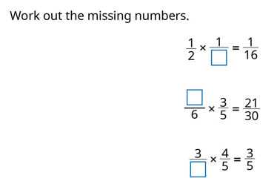

English
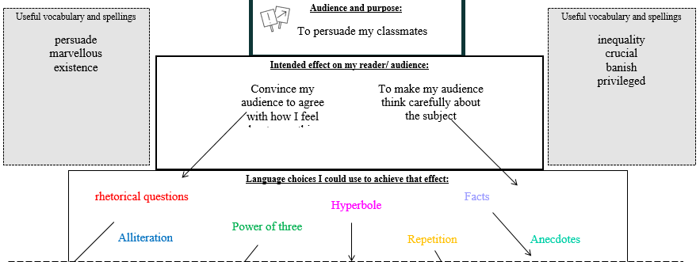
Spellings- recap
Grammar- tense
English
To know the features of persuasive speech
To compare speeches

PE
- Develop confidence to drive to the basket
- Use strength and coordination to drive and shoot
- Use crossover dribble to drive the basket

Science
L3 - To compare and give reasons for variations in how components function
L4 - To associate the volume of a buzzer with the number and voltage of cells used in the circuit.
L5 - To design and construct simple electric circuits for a purpose
L6 - To use and understand recognised symbols when representing a simple circuit in a diagram

Year 6
Autumn 2
Week six
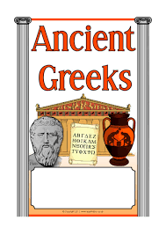


RE
Role of Mary as a protagonist

Reading
Word meaning- using context to support unfamiliar words
To answer literal questions
To answer inference questions

History
To understand some features of the Ancient Olympic games including the prizes given to competitors.
Art
To explore how artists use colour to express
themselves in their art.
Music
To rehearse for the carol concert

Homework and Spellings Autumn 2
Spellings  These will be tested on Monday | tious and cious  spacious  gracious  malicious  precious  ferocious  ambitious  cautious  repetitious  superstitious  scrumptious
Project | Can you design and cook a healthy meal? What makes it healthy?  Send any photos to
CGP books | Children are to complete one test from each book. These will be checked on a Monday. Please time the children so they have 10 minutes for each test.  The pages we would like them to answer will be in the front cover.
Messages | Christmas party – Thursday 18th December  Please bring any secret santa presents before then  Thank you  

Homework and Spellings Autumn 2 | Week beginning 9.12.24
Spellings  These will be tested on Monday | Please recap all spellings from this half term. The test will be a mix of all learnt.
Task | Can you design and cook a healthy meal? What makes it healthy?  Send any photos to y6hw@sacredheart312.herts.sch.uk
Messages | If you would like something extra:  Reading challenge (at the back of the homework diary)

