English
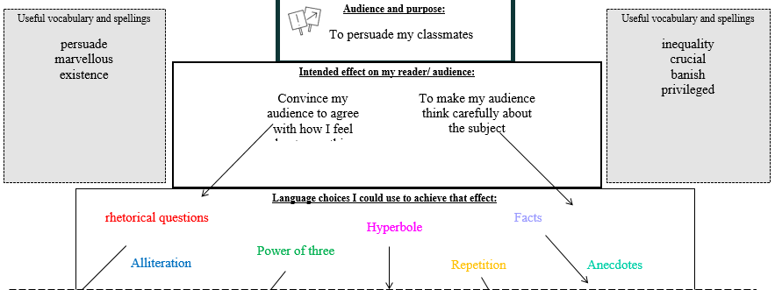
Spellings- able, ably, ible and ibly
Grammar- Active voice, adverbs, determiners
English
Select appropriate grammar and vocabulary, understanding how such choices can change and enhance meaning.

Maths (Example questions)
To mulitply a fraction by a fraction
To divide fractions
Fractions of amounts

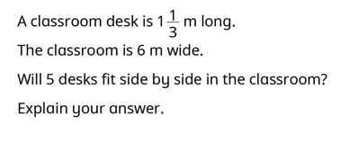

PE
- Develop confidence to drive to the basket
- Use strength and coordination to drive and shoot
- Use crossover dribble to drive the basket

Science
L3 - To compare and give reasons for variations in how components function
L4 - To associate the volume of a buzzer with the number and voltage of cells used in the circuit.
L5 - To design and construct simple electric circuits for a purpose
L6 - To use and understand recognised symbols when representing a simple circuit in a diagram

Year 6
Autumn 2
Week four
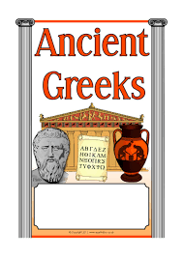


RE
Show understanding that Mary is the fulfilment of the Old Testament promises, making relevant links to Luke 1 and Matthew 1. (U6.2.3)

Reading
Word meaning- using context to support unfamiliar words
To answer literal questions
To answer inference questions

History
To understand how the city states effective daily life- Battle of Marathon

Art
To make clay pots
Music
To rehearse for the carol concert

Homework and Spellings Autumn 2
Spellings  These will be tested on Monday | horrible  valuable  identifiable  enjoyable  adorable  legible  edible  invincible  reversible  disposable
CGP books | Children are to complete one test from each book. These will be checked on a Monday. Please time the children so they have 10 minutes for each test.  The pages we would like them to answer will be in the front cover.
Messages | Dates to note  28th November – Advent Fayre  Wednesday 3rd December – carol concert  Thursday 4th December – swimming  Wednesday 17th December – Christmas lunch  Thursday 18th December- advent service

