English
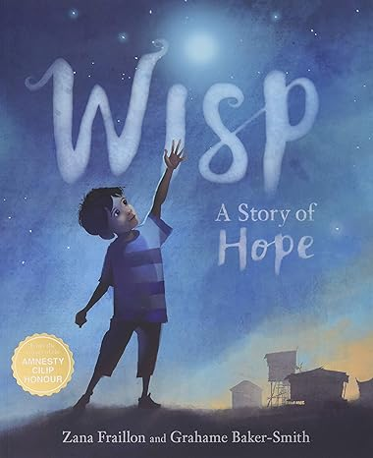
Spellings- cial, tial, cially, tially
Grammar- PASSIVE VOICE, commas
English
To use adverbials to enhance meaning
To describe settings, characters and atmosphere and integrate dialogue to convey character and advance the action.
Maths (Example questions)
To add mixed numbers
To subtract mixed numbers
To carry out mulitplstep fraction probelsm
To mulitply fractions

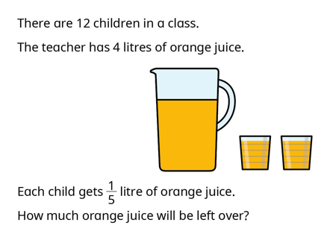

PE
Basketball lesson 3 to perform a free throw with consistency
Explore space and relationships in dance
Develop a movement phrase that incorporates at least two relationships and a spatial element

Science
To review children’s knowledge of forces
To understand that the Earth and objects are pulled towards each other and that this gravitational attraction causes objects to have weight.
Year 6
Autumn 2
Week three
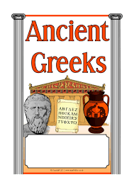


RE
describe the women of the Old Testament as true protagonists of salvation history.
Learn about Esther

Reading
Word meaning- using context to support unfamiliar words
To answer literal questions
To answer inference questions

History
Enquiry question- How did the city states differ in Ancient Greece focus on Sparta

Art
Using clay tools
Music
To rehearse for the carol concert

Homework and Spellings Autumn 2
Spellings  These will be tested on Monday | cial, tial, cially, tially  confidential  initial  commercial  official  financial  confidentially  commercially  officially  financially  initially
CGP books | Children are to complete one test from each book. These will be checked on a Monday. Please time the children so they have 10 minutes for each test.  The pages we would like them to answer will be in the front cover.
Project | Design and make a Christmas decoration for the classroom that reflects your personality.  Or  Write a Christmas card for your Buddy.
Messages | Decorate the classroom day Wednesday 19th November  Please remember to listen to your child read every day, Even if it is just a page, then record in their reading record.

Homework and Spellings Autumn 2 | Week beginning 18.11.24
Spellings  These will be tested on Monday | pound  money  cash  pence  coins  change  amount
Task | How many coins do you know?  How many notes do you know?  Can you
Project  DUE Friday 22nd November | Design and make a Christmas decoration for the classroom that reflects your personality.  Or  Write a Christmas card for your Buddy.
Messages | If you would like something extra:  Reading challenge (at the back of the homework diary)

