English

Spellings- ROOT WORDS
Grammar- HYPHENS, ACTIVE VOICE
English
To use adverbials to enhance meaning
To describe settings, characters and atmosphere and integrate dialogue to convey character and advance the action.
Maths (Example questions)
To put equivalent fractions on a number line
To compare and order fractions
To add and subtract fractions
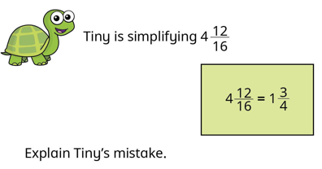

PE
Basketball lesson 3 to perform a free throw with consistency

Science
To review children’s knowledge of forces
To understand that the Earth and objects are pulled towards each other and that this gravitational attraction causes objects to have weight.
Year 6
Autumn 2
Week two
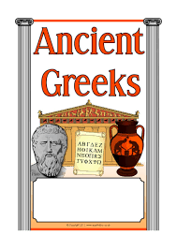

RE
Read & annotate Hannah’s Canticle.
Connect–Extend–Challenge
(link to Sarah & Mary).
Add Hannah to timeline.


Reading
Word meaning- using context to support unfamiliar words
To answer literal questions
To answer inference questions

Music
To rehearse for the carol concert
History
To infer what type of people the Ancient Greeks were by handling and observing artefacts.

Spellings  These will be tested on Monday | ROOT WORDS  determine  occupy  communicate  separate  explain  recommend  accommodate  appreciate  exaggerate  criticise
CGP books | Children are to complete one test from each book. These will be checked on a Monday. Please time the children so they have 10 minutes for each test.  The pages we would like them to answer will be in the front cover.
Project  DUE Friday 22nd November | Design and make a Christmas decoration for the classroom that reflects your personality.  Or  Write a Christmas card for your Buddy.
Messages | If you would like something extra:  Arithmetic aerobics  Reading challenge (at the back of the homework diary)

