Maths (Example questions)
To use mental calculations
To reason using known facts
Four rules assessmnet
Artrithmetic recap – add, subtract multiply, divide
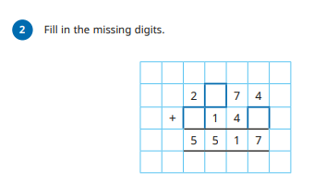

English

Spellings- ment, ful, ly suffix
Grammar- adverbs
English
To punctuate dialogue
To write a free form poem
To vary sentence structure

PE
To know how to counter attack using the fast break

Science
To review children’s knowledge of forces
To understand that the Earth and objects are pulled towards each other and that this gravitational attraction causes objects to have weight.
Year 6
Autumn 2
Week one
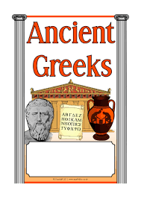

RE
Caritas lesson – preferential option of the poor
Justice 1 – TO understand what justice is
To reflect on injustice in society

Reading
Word meaning- using context to support unfamiliar words
To answer literal questions
To answer inference questions

Art
To explore how clothing can be used to express ourselves
Music
To rehearse for the carol concert
History
To infer what type of people the Ancient Greeks were by handling and observing artefacts.

Homework and Spellings Autumn 2
Spellings  These will be tested on Monday | -Ment, -ful, -ly, -less, -ness  embarrassment  spiteful  harassment  cautiously  environment  thoroughly  tremendously  business  colourful  pointless
CGP books | Children are to complete one test from each book. These will be checked on a Monday. Please time the children so they have 10 minutes for each test.  The pages we would like them to answer will be in the front cover.
Project  Due Friday 28th November | Design and make a Christmas decoration for the class Christmas tree that reflects your personality.
Messages | If you would like something extra:  Mathletics

