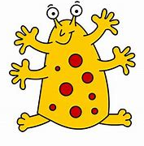  dat | bat
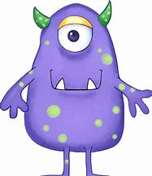  chib | fair
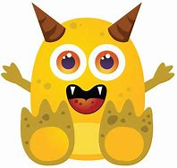  whid | stir
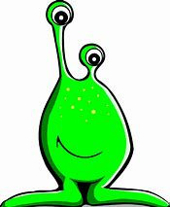  melp | swim
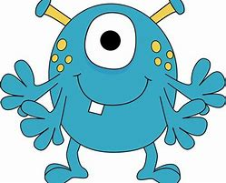  blorg | float
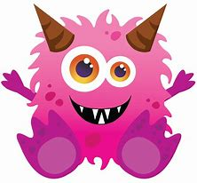  flighm | phone
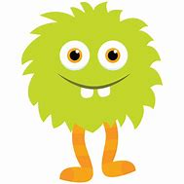  brift | stand
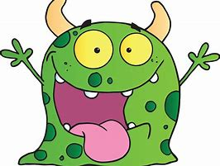  scroy | escape
  plaist | crunch
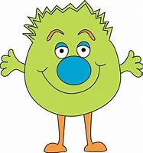  stribe | melting
vod | nut
thob | rain
clou | moon
freb | help
doost | clown
slarp | screw
gruft | frost
plawst | August
flend | spring
strebe | treetop
vid | sit
quan | burn
srie | team
helb | next
gloip | thing
shearf | stone
sprop | crust
flirg | sprout
thrend | twisting
harnds | printer
teb | fog
choav | clear
zlue | leaf
plap | felt
dairps | hooks
barst | cloud
glips | stamp
crirb | invite
blows | sandpit
shebber | children
zup | leg
choib | stay
spoe | white
frex | plum
sherbs | keeps
thist | cried
blemp | scrap
phoost | rescue
strarg | floating
trawps | lunchbox
beff | tip
tairg | soil
zude | meat
jesp | spin
plorg | start
sloam | these
trest | crisp
clane | nephew
chighps | drench
fooner | softest
reg | sun
farp | might
clie | play
bulm | lift
quaist | shorts
scrug | snake
blung | crept
whoats | thirteen
floost | shelter
 | sandwich
ind | bed
zeep | chair
croy | grew
fosp | clap
blarg | flight
strow | least
plest | spend
plawg | mountain
sloibs | handstand
thrayd | driftwood
yax | red
sheed | chip
prew | birth
cred | flag
bloog | coast
murts | slide
splam | trust
bloud | whisper
braits | scrunch
vorfin | handstand
fup | dog
slib | seen
zeam | fine
glog | dent
woats | stuck
grure | spray
slupt | twist
blies | launch
clisk | shrink
plairbs | helper
ved | sock
zlap | toe
quoyt | name
clothg | clue
fearg | shirt
huge | annoy
muret | kitchen
joem | autumn
phon | dentist
jairds | singing
quune | Shine
hile | Hide
fine | fine
splame | pine
lafe | slide
vate | white
penue | dislike
sheque | queue
phonit | rescue
hout | elephant
zaw | Claw
thawl | Paul
wheeb | whisper
splame | why
doe | dominoes
gloy | royal
flane | escape
fute | honey
glead | money
dea | repeat

