Maths
SATS ASSESMENT

Art
To understand what surrealism is in artwork.
English
SATS ASSESMENT

PE
To consolidate passing and moving in tag rugby
Swimming
Science
Identify and name a variety of common animals including fish, amphibians, reptiles, birds and mammals.
Identify and name a variety of common animals that are carnivores, herbivores and omnivores.
Describe and compare the structure of a variety of common animals (fish, amphibians, reptiles, birds and mammals, including pets)
Identify, name, draw and label the basic parts of the human body and say which part of the body is associated with each sense

Geography
How do natural hazards like earthquakes and wildfires impact people in California?

PSHE
I understand that my actions affect other people locally and globally
I understand my own wants and needs and can compare these with children in different communities

RE
Use theological vocabulary to explain how sin damages relationships
Harvest festival

Homework and Spellings Autumn 1
Spellings  These will be tested on Monday | 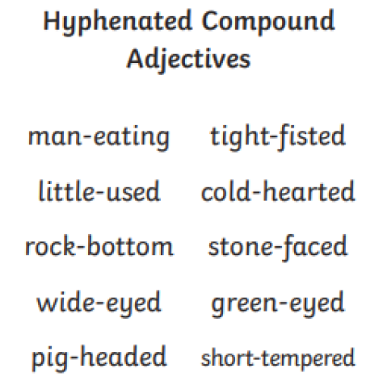
Arithmetic Aerobics | Check orange book
Messages | Please join us for our parent Tag rugby event on Monday 20th October at 2pm

